**Find Your Google Classroom**

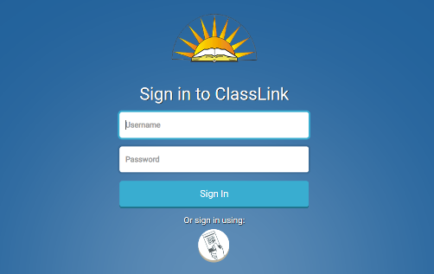

1. Begin by logging into ClassLink (launchpad.classlink.com/chino)
   1. Your teacher will provide your district username and password
   2. Use the Chrome browser
2. Tap on the Google Classroom app 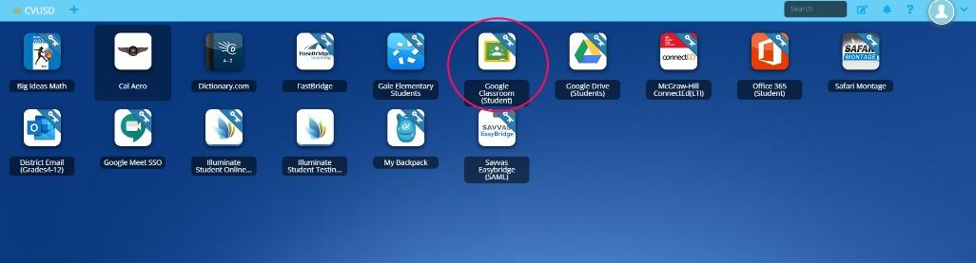
3. When the Google Classroom landing page opens, student should see teacher’s Google Classroom.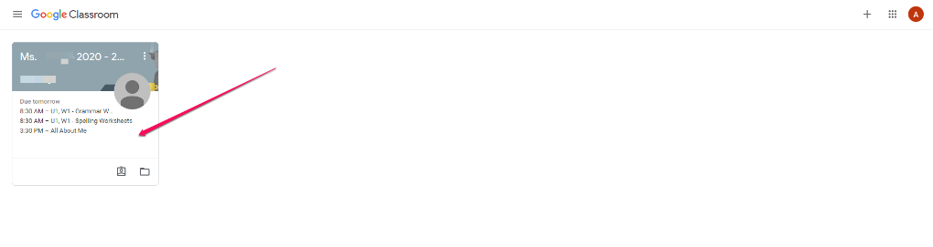
4. Tap Classroom to enter.